**Group Project Deployment Assignment**

**Students:**

Sami Nachwati, Michael Esenwa, Ryan Harris, Maurico Canul Quintal, Mari Shenzhen Uy

**Operation of Deployed System**

**Disclaimer:**

All primary functionalities from Lab 1 are operational, including **login, viewing home content, and navigation** across the system. No registration logic was implemented in the original Lab 1 code, which was maintained for consistency and correctness in deployment.

It is also important to note that the deployed Azure site occasionally **crashes on startup**. However, if our teammate Michael Esenwa opens the solution in Visual Studio and clicks the **“Publish”** button, the application reliably boots back up and functions as expected. This behaviour appears to stem from Azure’s hosting environment rather than any issue in the source code, as all deployment steps were completed correctly following the official tutorial.

**Access Instructions for Ethical Hackers:**

1. **URL:** <https://group8project-c3cedzc9b8hufueg.canadacentral-01.azurewebsites.net/>
2. **Registration Disclaimer:**
   1. The original Lab 1 did not include registration functionality, and this has been intentionally maintained. Instead, pre-seeded users are provided to support testing access — as permitted by the professor’s note.
3. **Login Instructions:**
   1. Proceed to click the *Login* navigation item in the top right of the screen

* 1. Next, proceed to login with registered account, for instance, using the supervisor email (the.supervisor@mohawkcollege.ca) and password (Password!5). In addition, you can also use the employee email of: [the.employee@mohawkcollege.ca](mailto:the.employee@mohawkcollege.ca) with the same password.

* 1. Now, logged-in user will be able to see the home page

1. **Navigation** **instructions For Supervisor**:
   1. Additionally, a supervisor is able to create a message when navigating to **Messages** and entering their desired message then proceeding to click **Create**

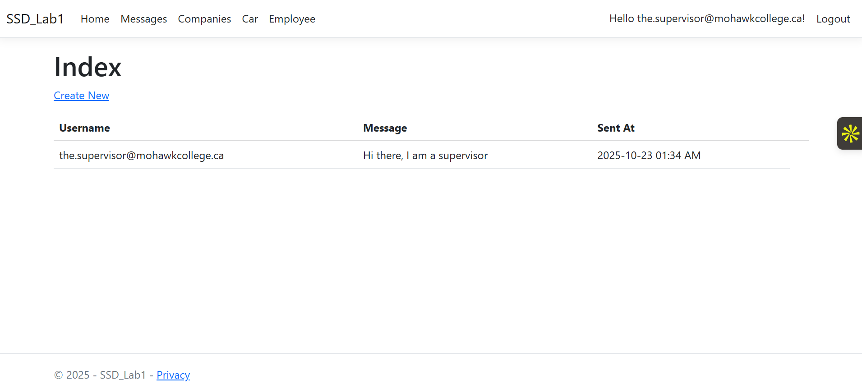



* 1. A Supervisor is able to View the details of a company after navigating to **Companies** Navigation item and clicking the **Details** button:

* 1. A Supervisor is also able to edit a company

* 1. As well as deleting a company

* 1. Supervisors can also Create a new company



* 1. A Supervisor can also visit Car and Employee tabs and Create, View, Edit, and Delete.

1. **Navigation Instructions for Employee**
   1. Home page redirect upon successful login using email of [the.employee@mohawkcollege.ca](mailto:the.employee@mohawkcollege.ca) and password of Password!5

* 1. Employees can also create messages.

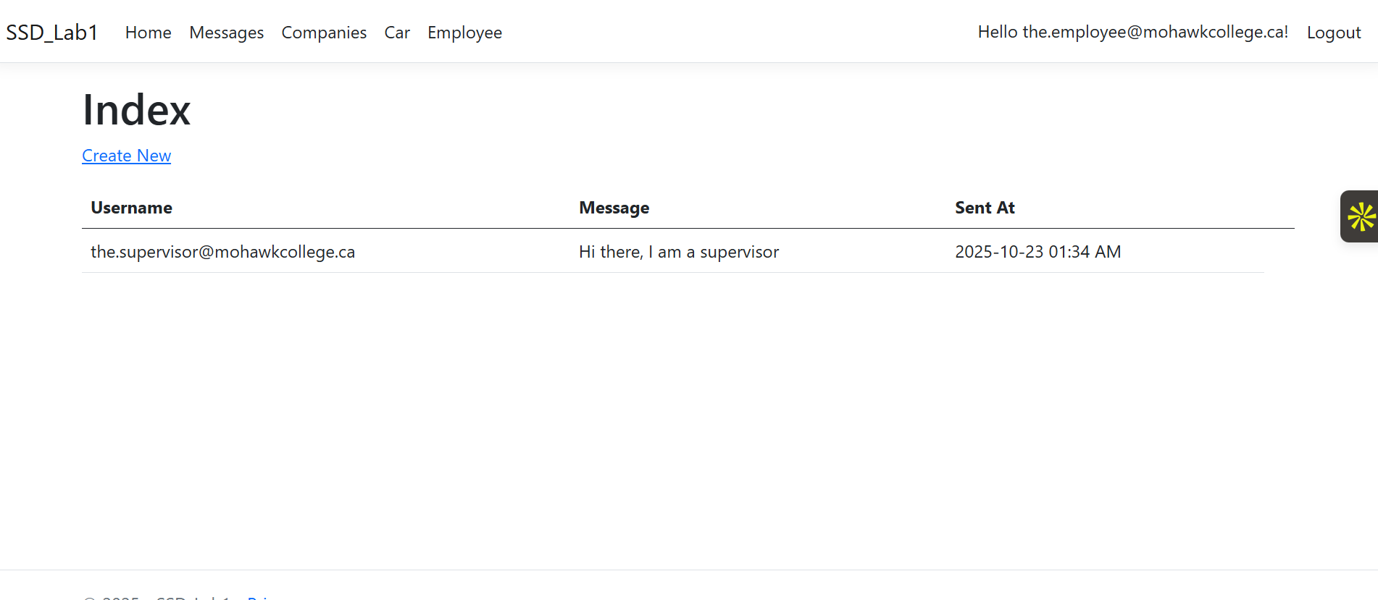



* 1. Employees can only view the details of a company, but not Create, Edit, or Delete.



* 1. Employees can also create Cars



* 1. Employees can also view the details of a car and edit them, as well as deleting them

* 1. Employees can also Create, View, Edit, and Delete employees

1. **Build Instructions:**
   1. Visit the GitHub link (<https://github.com/epicwizzle/Group_8_project>)
   2. Next, click the “<> Code” button, then press the “Download ZIP” option

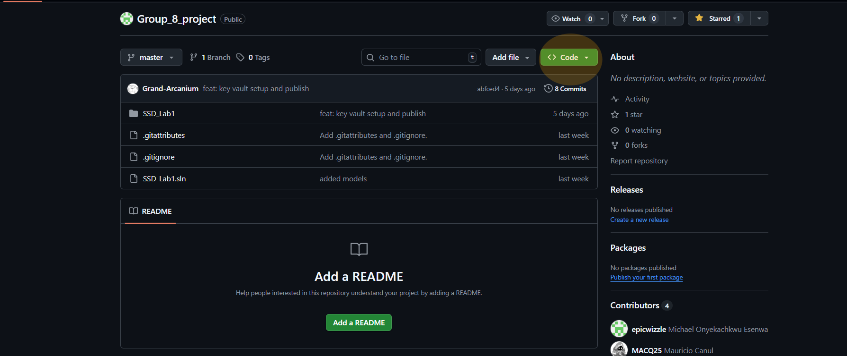

* 1. Extract the contents of the files and then open the folder in Visual Studio
  2. Once that is done, click the *https* start button with its arrow fully green, which would run the project in *Debug Mode*
  3. **DISCLAIMER**: You must have a linked Key Vault to an existing azure account that corresponds to the Key Vault registered. However, because this was locally developed into a personal lab *originally*, this means that a regular user who attempts to clone the repository will not be able to run the application for actual local development/running.

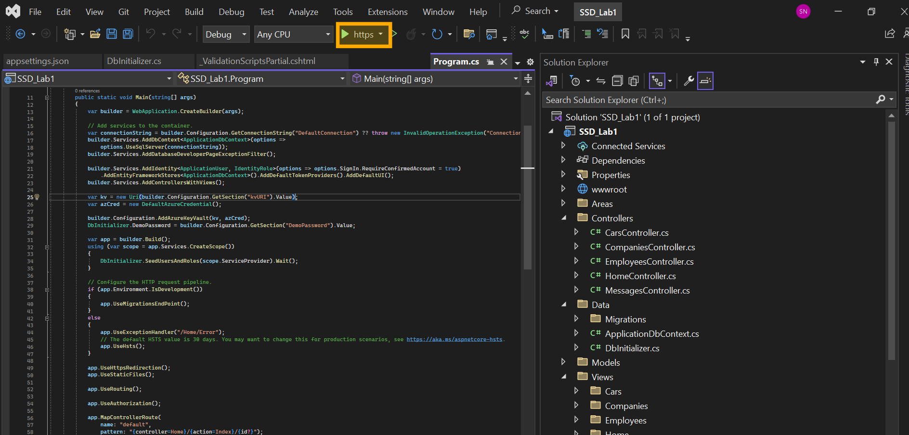

**GitHub Source Code:** <https://github.com/epicwizzle/Group_8_project>

**Deployed Site:** <https://group8project-c3cedzc9b8hufueg.canadacentral-01.azurewebsites.net/>